R is one of the best choices when it comes to *quantitative finance*. Here we will show you how to load financial data, plot *charts* and give you a step-by-step template to *backtest trading strategies*. So, read on…

We begin by just plotting a chart of the *Standard & Poor’s 500 (S&P 500)*, an index of the 500 biggest companies in the US. To get the index data and plot the chart we use the powerful quantmod package (on CRAN). After that we add two popular *indicators*, the *simple moving average (SMI)* and the *exponential moving average (EMA)*.

Have a look at the code:

library(quantmod)

## Loading required package: xts

## Loading required package: zoo

##

## Attaching package: 'zoo'

## The following objects are masked from 'package:base':

##

## as.Date, as.Date.numeric

## Loading required package: TTR

## Version 0.4-0 included new data defaults. See ?getSymbols.

getSymbols("^GSPC", from = "2000-01-01")

## 'getSymbols' currently uses auto.assign=TRUE by default, but will

## use auto.assign=FALSE in 0.5-0. You will still be able to use

## 'loadSymbols' to automatically load data. getOption("getSymbols.env")

## and getOption("getSymbols.auto.assign") will still be checked for

## alternate defaults.

##

## This message is shown once per session and may be disabled by setting

## options("getSymbols.warning4.0"=FALSE). See ?getSymbols for details.

## [1] "^GSPC"

head(GSPC)

## GSPC.Open GSPC.High GSPC.Low GSPC.Close GSPC.Volume

## 2000-01-03 1469.25 1478.00 1438.36 1455.22 931800000

## 2000-01-04 1455.22 1455.22 1397.43 1399.42 1009000000

## 2000-01-05 1399.42 1413.27 1377.68 1402.11 1085500000

## 2000-01-06 1402.11 1411.90 1392.10 1403.45 1092300000

## 2000-01-07 1403.45 1441.47 1400.73 1441.47 1225200000

## 2000-01-10 1441.47 1464.36 1441.47 1457.60 1064800000

## GSPC.Adjusted

## 2000-01-03 1455.22

## 2000-01-04 1399.42

## 2000-01-05 1402.11

## 2000-01-06 1403.45

## 2000-01-07 1441.47

## 2000-01-10 1457.60

tail(GSPC)

## GSPC.Open GSPC.High GSPC.Low GSPC.Close GSPC.Volume

## 2019-04-24 2934.00 2936.83 2926.05 2927.25 3448960000

## 2019-04-25 2928.99 2933.10 2912.84 2926.17 3425280000

## 2019-04-26 2925.81 2939.88 2917.56 2939.88 3248500000

## 2019-04-29 2940.58 2949.52 2939.35 2943.03 3118780000

## 2019-04-30 2937.14 2948.22 2924.11 2945.83 3919330000

## 2019-05-01 2952.33 2954.13 2923.36 2923.73 3645850000

## GSPC.Adjusted

## 2019-04-24 2927.25

## 2019-04-25 2926.17

## 2019-04-26 2939.88

## 2019-04-29 2943.03

## 2019-04-30 2945.83

## 2019-05-01 2923.73

chartSeries(GSPC, theme = chartTheme("white"), subset = "last 10 months", show.grid = TRUE)

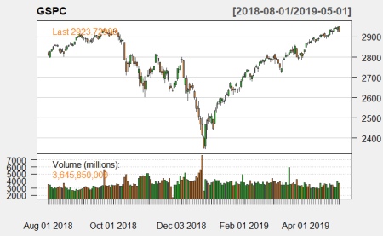

addSMA(20)

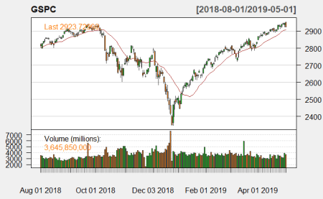

addEMA(20)

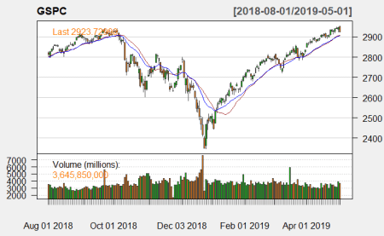

As you can see the moving averages are basically smoothed out versions of the original data shifted by the given number of days. While with the SMA (red curve) all days are weighted equally with the EMA (blue curve) the more recent days are weighted stronger, so that the resulting indicator detects changes quicker. The idea is that by using those indicators investors might be able to detect longer term trends and act accordingly. For example a trading rule could be to buy the index whenever it crosses the MA from below and sell when it goes the other direction. Judge for yourself if this could have worked.

Well, having said that it might not be that easy to find out the profitability of certain trading rules just by staring at a chart. We are looking for something more systematic! We would need a decent *backtest*! This can of course also be done with R, a great choice is the PerformanceAnalytics package (on CRAN).

To backtest a trading strategy I provide you with a step-by-step template:

1. Load libraries and data
2. Create your indicator
3. Use indicator to create equity curve
4. Evaluate strategy performance

As an example we want to test the idea that it might be profitable to sell the index when the financial markets exhibit significant stress. Interestingly enough “stress” can be measured by certain *indicators* that are freely available. One of them is the *National Financial Conditions Index (NFCI)* of the *Federal Reserve Bank of Chicago* (<https://www.chicagofed.org/publications/nfci/index>):

The Chicago Fed’s National Financial Conditions Index (NFCI) provides a comprehensive weekly update on U.S. financial conditions in money markets, debt and equity markets and the traditional and “shadow” banking systems. […] The NFCI [is] constructed to have an average value of zero and a standard deviation of one over a sample period extending back to 1971. Positive values of the NFCI have been historically associated with tighter-than-average financial conditions, while negative values have been historically associated with looser-than-average financial conditions.

To make it more concrete we want to create a *buy signal* when the index is above one standard deviation in negative territory and a *sell signal* otherwise.

Have a look at the following code:

# Step 1: Load libraries and data

library(quantmod)

library(PerformanceAnalytics)

##

## Attaching package: 'PerformanceAnalytics'

## The following object is masked from 'package:graphics':

##

## legend

getSymbols('NFCI', src = 'FRED', , from = '2000-01-01')

## [1] "NFCI"

NFCI <- na.omit(lag(NFCI)) # we can only act on the signal after release, i.e. the next day

getSymbols("^GSPC", from = '2000-01-01')

## [1] "^GSPC"

data <- na.omit(merge(NFCI, GSPC)) # merge before (!) calculating returns)

data$GSPC <- na.omit(ROC(Cl(GSPC))) # calculate returns of closing prices

# Step 2: Create your indicator

data$sig <- ifelse(data$NFCI < 1, 1, 0)

data$sig <- na.locf(data$sig)

# Step 3: Use indicator to create equity curve

perf <- na.omit(merge(data$sig * data$GSPC, data$GSPC))

colnames(perf) <- c("Stress-based strategy", "SP500")

# Step 4: Evaluate strategy performance

table.DownsideRisk(perf)

## Stress-based strategy SP500

## Semi Deviation 0.0075 0.0087

## Gain Deviation 0.0071 0.0085

## Loss Deviation 0.0079 0.0095

## Downside Deviation (MAR=210%) 0.0125 0.0135

## Downside Deviation (Rf=0%) 0.0074 0.0087

## Downside Deviation (0%) 0.0074 0.0087

## Maximum Drawdown 0.5243 0.6433

## Historical VaR (95%) -0.0173 -0.0188

## Historical ES (95%) -0.0250 -0.0293

## Modified VaR (95%) -0.0166 -0.0182

## Modified ES (95%) -0.0268 -0.0311

table.Stats(perf)

## Stress-based strategy SP500

## Observations 4858.0000 4858.0000

## NAs 0.0000 0.0000

## Minimum -0.0690 -0.0947

## Quartile 1 -0.0042 -0.0048

## Median 0.0003 0.0005

## Arithmetic Mean 0.0002 0.0002

## Geometric Mean 0.0002 0.0001

## Quartile 3 0.0053 0.0057

## Maximum 0.0557 0.1096

## SE Mean 0.0001 0.0002

## LCL Mean (0.95) -0.0001 -0.0002

## UCL Mean (0.95) 0.0005 0.0005

## Variance 0.0001 0.0001

## Stdev 0.0103 0.0120

## Skewness -0.1881 -0.2144

## Kurtosis 3.4430 8.5837

charts.PerformanceSummary(perf)

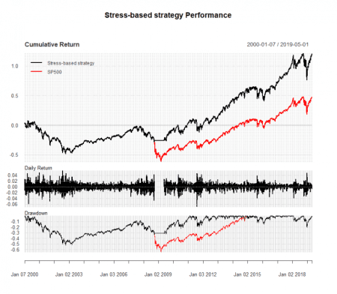

chart.RelativePerformance(perf[ , 1], perf[ , 2])

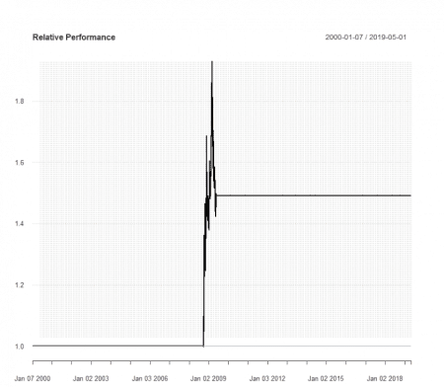

chart.RiskReturnScatter(perf)

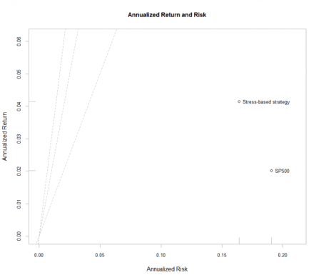

The first chart shows that the stress-based strategy (black curve) clearly outperformed its *benchmark*, the S&P 500 (red curve). This can also be seen in the second chart, showing the relative performance. In the third chart we see that both return (more) and (!) risk (less) of our backtested strategy are more favourable compared to the benchmark.

So, all in all this seems to be a viable strategy! But of course before investing real money many more tests have to be performed! You can use this framework for backtesting your own ideas.

Here is not the place to explain all of the above tables and plots but as you can see both packages are very, very powerful and I have only shown you a small fraction of their capabilities. To use their full potential you should have a look at the extensive documentation that comes with it on CRAN.

**Disclaimer:  
This is no investment advice! No responsibility is taken whatsoever if you lose money!**

If you gain money though I would be happy if you could buy me a coffee… that is not too much to ask, is it?